LM2596 IC

Design Parameters for the adjustable version of the chip

[Mouser Link](https://www.mouser.com/ProductDetail/Texas-Instruments/LM2596T-ADJ-LF02?qs=X1J7HmVL2ZFra1iCTKD7LA%3D%3D)

|  |  |
| --- | --- |
| Parameter | Value |
| Regulated Output Voltage | 5V |
| Maximum DC Input | 12.5V |
| Maximum Load Current | 2A |
| Switching Frequency | 150kHz (FIXED) |

***Feedback Output Resistors***

* Use resistors with 1% tolerance
$$V_{OUT}=V_{REF}\left(1+\frac{R_{2}}{R_{1}}\right)$$

$$V_{REF}=1.23V$$

* Select $240 Ω≤R_{1}≤1.5kΩ$

To find $R_{2}$

$$R_{2}=R_{1}\left(\frac{V_{OUT}}{V_{REF}}-1\right)$$

Let $R_{1}=1kΩ$

$$R_{2}=1kΩ\left(\frac{5V}{1.23V}-1\right)=3065 Ω=3.065kΩ$$

$$R_{2}=3.065kΩ*0.01=3.0957kΩ$$

***Inductor Selection***

$$E⋅T=\left(V_{IN}-V_{OUT}-V_{SAT}\right)⋅\frac{V_{OUT}+V_{D}}{V_{IN}-V_{SAT}+V_{D}}⋅\frac{1000}{150 }$$

where and

L40 = rated at 3.50A select the inductor PE-54040 ($38 μH$)

***Output Capacitor Design***

* Low ESR Electrolytic or Solid Tantalum Capacitors
  + Between 82uF and 820uF provides best results
  + Must be placed close to the IC using short capacitor leads and short copper traces
  + Do NOT exceed 820uF
* Use Table 9-6 from the Datasheet
* Generally, the voltage rating of the capacitor must be at least 1.5x than the output voltage
* Other manufacturers can be used but the specifications (100kHz ESR) must closely match Table 9-6

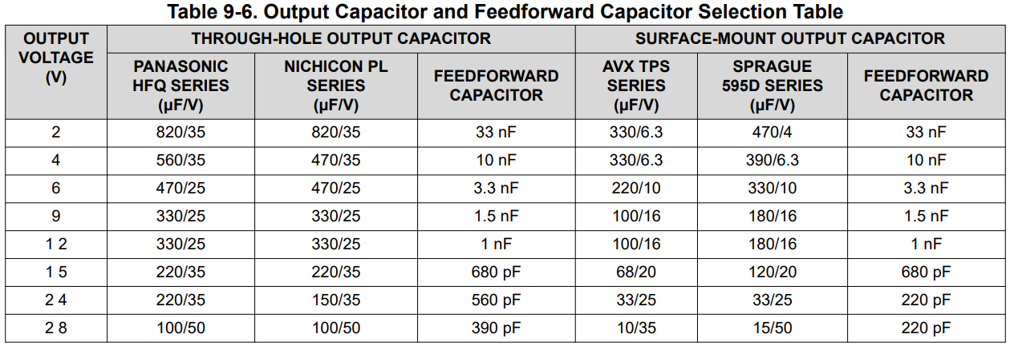

Select the closest value to the output voltage. Since our output is 5V, we look at 6V in the table

From the table, this is our output capacitor:

* Through-hole Capacitor
  + 470uF 25V Panasonic HFQ Series
  + 470uF 25V Nichicon PL Capacitor
* Surface-Mount Capacitor
  + 220uF 10V AVX TPS Series
  + 330uF 10V Sprague 595D Series

We will use through-hole capacitor

***Feedforward Capacitor***

* Examine Table 9-6
* For output voltages greater than ~10V, an additional capacitor is needed
  + Compensation Capacitor must be wired in parallel with the R2 resistor
  + Values must be between 100pF and 33nF
* This is the calculation for Feedforward Capacitor (used with other manufacturers outside Table 9-6)
$$C_{FF}=\frac{1}{31×{10}^{3}×R_{2}}$$

* Can be Ceramic, Plastic, Silver Mica, etc.
* Not recommended with ceramic capacitors made with Z5U material

Thus, from Table 9-6, our feedforward capacitor is a 3.3nF (let us use a ceramic capacitor)

***Catch Diode Selection (D1)***

* Must be at least 1.3x greater than the maximum load current you specified
  + Our max is 2A * 1.3 = 2.6A. So diode current must be greater than 2.6A (let us say 3A)
* If the power supply design must withstand a continuous output short, the diode current must be equal to the maximum current limit of the LM2596 (3A max)
* Schottky Diode provides the best performance
* Reverse Voltage Rating must be at least 1.25x the maximum input voltage
  + Our max is 12.5*1.25 = 15.625. So Reverse Voltage of 15.625V or greater (let us say 16V for reverse voltage)
* Diode must have fast short reverse recovery time and must be placed close to the LM2596 using short leads and short printed circuit traces (typically 50ns or less)
* Examine Table 9-4 for the selection

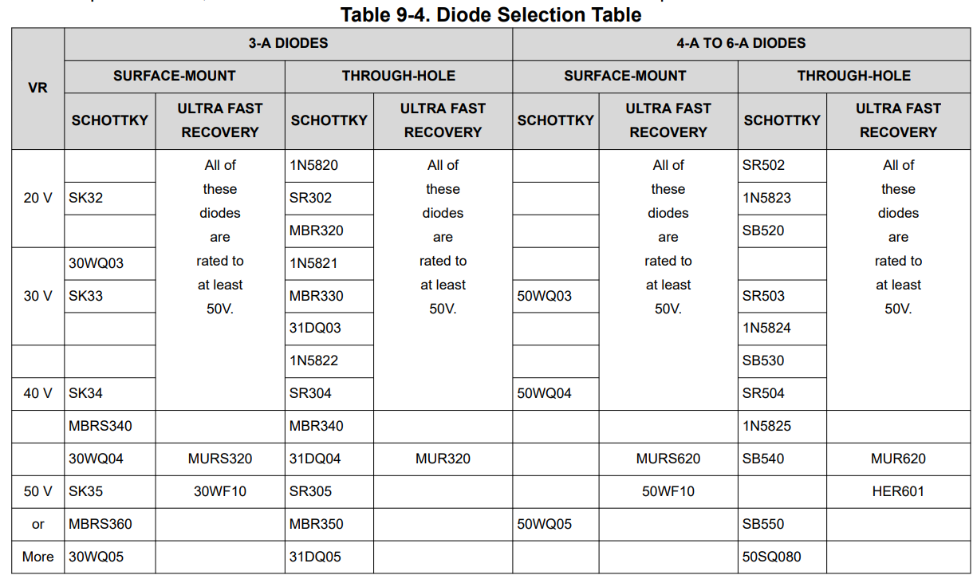

So we want a 3A Schottky Diode with Reverse Voltage Greater than 15.625V. From the table above, we can use a 20V 3A Schottky Diode (1N5820, SR302, and MBR320)

***Input Capacitor***

* Low ESR Aluminum or Tantalum Bypass Capacitor is required between the input pin and the ground pin to prevent large voltage transients from appearing at the input
* RMS current rating must be at least ½ the DC load current
  + For our case, 0.5 * 2A = 1A
  + Manufacturer data sheet must be checked to assure that this capacitor rating is not exceeded
* Must be placed closed to the IC using short leads and the voltage rating must be ~1.5x Vin
  + 1.5 * 12.5 = 18.75V
* If solid tantalum input capacitors are used, TI recommends that the surge current must be tested by the manufacturer
  + As a result, use the ones recommended in Table 9-1
* Use Caution when using high dielectric constant ceramic capacitors for input bypassing as it can cause severe ringing at the Vin pin
* Examine Figure 9-1

Use either 470uF at 20V or 680uF at 20V. Let us pick 680uF at 20V

We are done with designing the adjustable 5V LM2596 Design. Let us find the parts and simulate it in NI Multisim

LM2596 5V Fixed Output Voltage Design

[Mouser](https://www.mouser.com/ProductDetail/Texas-Instruments/LM2596T-5.0?qs=X1J7HmVL2ZHGhhjJIS7EQw%3D%3D)

|  |  |
| --- | --- |
| Parameter | Value |
| Regulated Output Voltage | 5V (FIXED) |
| Maximum DC Input | 12.5V |
| Maximum Load Current | 2A |
| Switching Frequency | 150kHz (FIXED) |

Option 1: Use WEBBENCH (automatically gives you component values and which manufacturer – also simulates it)

Option 2: Direct Selection

Inductor Selection (L1)

* Use Figure 9-5, 9-6, or 9-7 for 3.3V, 5V, and 12V respectively
* For our case, we use Figure 9-6 since we want 5V

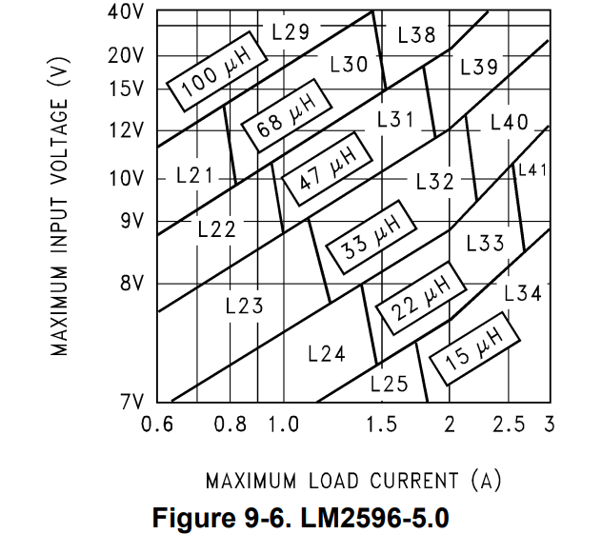

Looks like the intersection between 12.5V max input voltage and 2A max load current is L39 with 47uH or L32 with 33uH.

* From Table 9-1,
  + L32 (33uH, 2.5A)
    - Schottky Diode (67144160 for Through-Hole or 67144540 for SMD)
    - Renco Diode (RL-5471-7 for Through-Hole Only)
    - Pulse Engineering (PE-53932 for Through-Hole or PE-53932-S for SMD)
    - Coilcraft (DO5022P-333)
  + L39 (47uH, 3.5A)
    - Schottky Diode (67144210 for Through-Hole Only)
    - Renco Diode (RL-5472-3 for Through-Hole Only)
    - Pulse Engineering (PE-54039 for Through-Hole or PE-54039-S for SMD)
* Let us start using L32 Pulse Engineering Through-Hole in our simulation and then L39 if it does not work

Capacitor Output Selection

* Low ESR Electrolytic Capacitor between 82uF and 820uF AND Low ESR Solid Tantalum Capacitors between 10uF and 470 uF provide the best results
* Place close to the IC using short capacitor leads and short copper traces
* No larger value than 820uF
* Use Table 9-3 to make things simpler



From the table, our max input voltage is 12.5V and our max load current is 2A but the table has us using 20V line, so our capacitor can either be Panasonic HFQ Series Through-Hole Capacitors, Nichicon PL Series Through-Hole Capacitors, AVX-TPS Surface-Mount, or Sprague 595D Surface Mount

We will pick the Through-Hole Capacitors

* Panasonic HFQ or Nichicon PL Series (180uF / 35V)

Note: Capacitor Voltage Rating for Electrolytic Capacitors must be at least 1.5x greater than the output voltage

* So for 5V, it must be at least 7.5V or more
* Higher Voltage Rating often satisfy low ESR requirements (16-25V reduces the ripple)

Catch Diode Selection (D1)

* Current rating must be at least 1.3x greater than the maximum load current
* If the power system design must withstand a continuous output short, the diode must have a current rating equal to the maximum current limit of the LM2596 (3A)
* Reverse voltage rating must be at least 1.25x the maximum input voltage
* Diode must be fast (short reverse recovery time) and must be placed close to the IC. The ultra-fast recovery is 50ns or less typically. Recitifers are not recommended. Schottky is the best
* Use Table 9-4
  + Our current rating for diode (2A * 1.3 = 2.6A so let us say 3A)
  + Our reverse voltage rating (12.5*1.25 = 15.625V so let us say 20V)

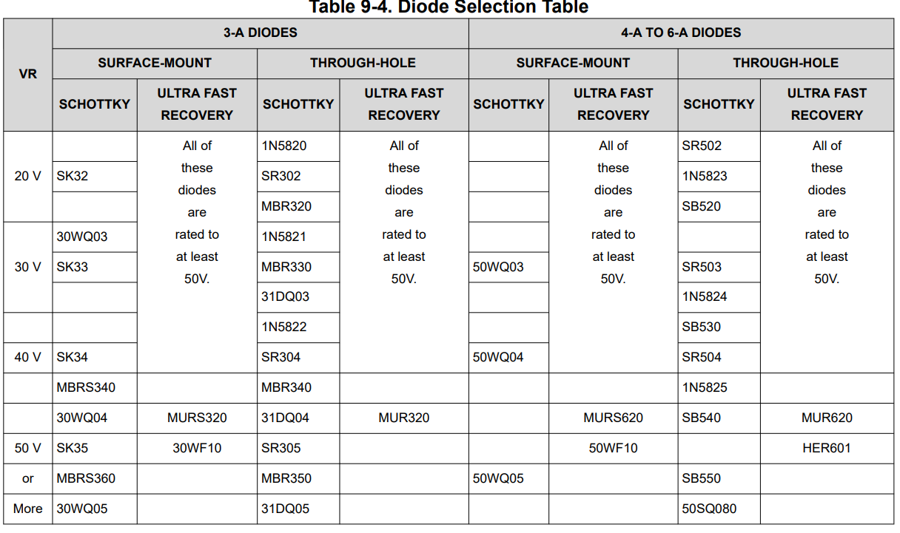

So let us choose either through-hole Schottky diodes (1N5820, SR302, or MBR320)

Capacitor Input Selection

* A low ESR aluminum or tantalum bypass capacitor is required between the input pin and ground pin to prevent large voltage transients
* Capacitors must be close to the IC
* RMS current rating should be at least ½ of the DC load current
* For aluminum electrolytic, capacitor voltage must be at least 1.5x the maximum input voltage
* Use caution for solid tantalum capacitors as its voltage rating should be at least 2x the maximum input and surge tested
* Use caution for ceramic capacitors due to severe ringing at the Vin pin
* Use Figure 9-1
  + Using low ESR aluminum electrolytic capacitors
  + RMS current rating: 2*0.5 = 1A
  + Voltage rating: 12.5*1.5 = 18.75V -> 20V

Pick either 470uF at 20V capacitor or 680uF at 20V. Let us choose 470uF at 20V for now

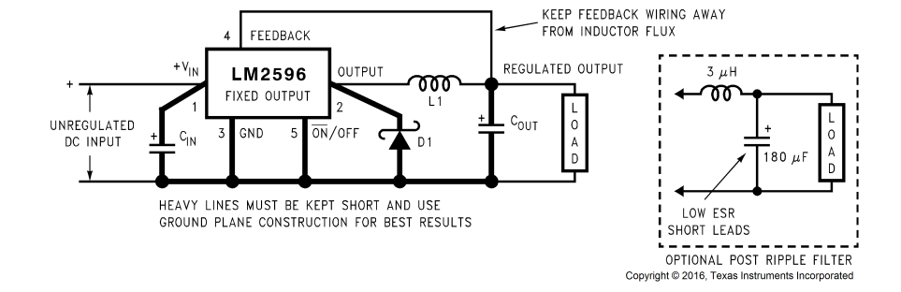

We are done with the design. Let us simulate in NI Multisim

Circuit Components for Adjustable Version

|  |  |
| --- | --- |
| Components | Value |
| R1 (Feedback Resistor) | $1kΩ$ at 1% tolerance |
| R2 (Feedback Resistor) | $3.065 kΩ$ at 1% tolerance |
| Cout (Output Capacitor) | 470uF/ 25V Panasonic HFQ Series (EE__)  470uF/ 25V Nichicon PL Capacitor |
| Cff (Feedforward Capacitor) | 3.3nF Ceramic Capacitor |
| Cin (Input Capacitor) | 470uF/ 20V Aluminum Electrolytic Capacitor  680uF/ 20V Aluminum Electrolytic Capacitor |
| D1 (Catch Diode) | 20V 3A 1N5820, SR302, and MBR320 |
| L1 (Inductor) | 38uH 3.5A PE-54040 |

Circuit Components for Fixed 5V 2A version

|  |  |
| --- | --- |
| Components | Value |
| Cout (Output Capacitor) | 180uF/ 35V Panasonic HFQ Series (EE__)  180uF/ 35V Nichicon PL Capacitor  ***180uF/35V 35SEK180M*** |
| Cin (Input Capacitor) | 470uF/ 20V Aluminum Electrolytic Capacitor  680uF/ 20V Aluminum Electrolytic Capacitor  ***470uF/35V EEHAZS1V471B*** |
| D1 (Catch Diode) | 20V 3A **1N5820**, SR302, and MBR320 |
| L1 (Inductor) | 33uH 2.5A   * 67144160 Schottky Diode * RL-5471-7 by Renco * PE-53932 by Pulse Engineering * DO5022P-333 by Coilcraft * ***12RS333C by Murata Power Corp***   47uH 3.5A   * 67144210 by Schottky * RL-5472-3 by Renco * PE-54039 by Pulse Engineering |

Note if Multisim cannot converge change:

* ABSTOL to 1e-06
* VNTOL to 1e-03
* RELTOL to 0.01
* Transient Integration Method to Gear

LM2596 5V 3A Version

|  |  |
| --- | --- |
| Parameter | Value |
| Regulated Output Voltage | 5V (FIXED) |
| Maximum DC Input | 12.5V |
| Maximum Load Current | 3A |
| Switching Frequency | 150kHz (FIXED) |

Inductor Selection



Inductor Code: L40. Value: 33uH rated at 3.5A

Choices: 67144220 (Schott), RL-5472-4, PE-54040, 744770133 by Wurth Elektronik

Capacitor Output

Capacitor required: 330uF/35V Panasonic Electrolytic Capacitors.

Choice: EEHAZK1V331B

Diode Selection

* 1.3 x 3 = 3.9A => 5A

Diode required: 20V 5A 1N5823, SB520, SR502. We choose SB520

Capacitor Input Selection

* 3 * 0.5 = 1.5A rms at 35V

Capacitor Required: 680uF 35V or 470uF 50V or 330uF 60V

Choice: EEUFK1V681L

|  |  |
| --- | --- |
| Inductor | 744770133 (33uH 3.2A) |
| Capacitor Output | EEHAZK1V331B (330uF 35V) |
| Capacitor Input | EGPA350ELL681MK20S (680uF 35V) |
| Diode | SB520 (20V 5A Schottky Diode) |